Alaska Rural Systemic Initiative
High School Mathematics Problems from Alaska

AL-CAN Highway Problem

Mary Lou Smart
Southeast Island School District
msmart@sisd.k12.ak.us

Standards: Measurement, Functions and Relationships.

Performance Standards: A2.3.2, A2.4.2, A2.4.3, A4.3.2, A4.3.4, A4.3.5

Concepts: Creating a table of ordered pairs, using variables (dependent and independent), writing equations, converting metric and standard measurements for distance using mileposts.

Carnegie Chapter: Modeling Situations with formulas, Tables of Values, and Graphs.

Overview: The student will write and solve equations converting between metric and standard measurement as they travel southeast on the Al-Can Highway.
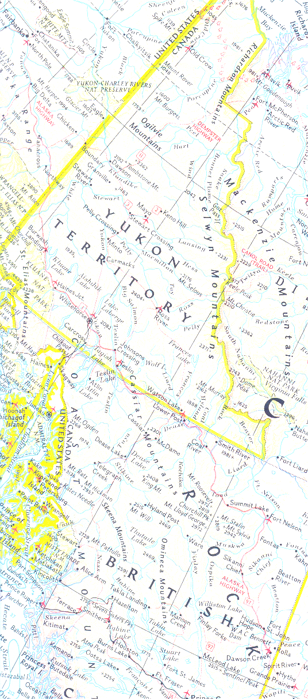
Alaska-Canada Highway

Task 1

We are going on a trip on the Alaska-Canada (Al-Can) Highway traveling southeast toward Dawson Creek. We begin our trip at Delta Junction, which is milepost number 1422, meaning that it is located 1422 miles from the origin of the Al-Can at Dawson Creek, BC. We will be traveling at 60 miles per hour starting at milepost 1422.

- At what milepost will we be if we drive for:

  - five hours?

  - eight hours?

  - Write a complete sentence describing how you found these answers.

  - Write an algebraic equation for this problem. Define any variables.

- Use the equation you created in question 1d to find out the milepost we are at after traveling for 11 hours at 60 miles an hour. Solve this equation, showing your work, and write your answer in a complete sentence.

- When we arrive at Port Alcan (the US-Canadian border), we are at milepost 1222. Write an equation you can use to find how long it took you to travel from Delta Junction to Port Al-Can. Solve this equation, showing your work, and write your answer in a complete sentence.

- Use the information from questions 1-3 to complete this table.

Labels
Units
Expressions
5
8
11
1222
1152

- Graph the equation for this problem situation. Label axes and number the intervals to show scale.

- Extension problem – While at Port Al-Can, we meet some fellow Alaskans who want to know how long it should take them to reach Fairbanks (milepost 1520) if their average speed is 60 miles an hour. Write an equation for this problem situation. Solve this equation, showing your work, and write your answer in a complete sentence. Explain how you solved this equation.

Alaska-Canada Highway

Task 2

When we enter the Yukon Territory, we find that Canadians designate distances on the Al-Can with kilometreposts. We know that 1 mile equals 1.6 kilometers.

- How many kilometers are there in:

  - 200 miles?

  - 500 miles?

  - Write a complete sentence describing how you found these answers.

- Write an equation you can use to find how much time it will take us at 60 miles an hour to reach Whitehorse, kilometrepost 1425, from Port Alcan. Solve this equation, showing your work, and write your answer in a complete sentence. Write a sentence describing how you solved the equation.

- Write an equation you can use to find out what kilometrepost we will be at if we continue an average speed of 60 miles an hour and we travel an additional three and a half hours from Whitehorse. Solve this equation, showing your work, and write your answer in a complete sentence.

- Write an equation you can use to find out how many more miles we need to travel to reach Fort Nelson, which is at kilometrepost 456, after we have traveled six hours from Whitehorse. Solve this equation, showing your work, and write your answer in a complete sentence.

- Write an equation you can use to find out how much time it will take to reach Dawson Creek, which is at kilometrepost 0, after we have traveled two hours from Fort Nelson. Solve this equation, showing your work, and write your answer in a complete sentence.

- Use the information from questions 2-5 to complete this
table.

Labels
Units
Expressions
530.2
3.5
6
264

- Use the table to graph the equation for this problem situation. Label axes and show the scale.



- Since the speed we traveled in both Alaska and Canada remained the same, how do you adjust the increments on your graphs so that the slopes are congruent? Graph both equations using these increments. Be sure to label axes, indicate intervals, and create a title for the graph.

Addendum to Alaska-Canada Highway, Tasks 1 and 2

Actual driving distance from Dawson Creek to Fairbanks is approximately 1,488 miles.

Driving Distances
Driving distances in miles and kilometers between major points on the Alaska Highway, from south to north, are as follows:

* Dawson Creek to Fort St. John, 47 miles / 76 km
* Fort St. John to Fort Nelson, 236 miles / 380 km
* Fort Nelson to Watson Lake, 330 miles / 531 km
* Watson Lake to Whitehorse, 272 miles / 438 km
* Whitehorse to Haines Junction, 100 miles / 161 km
* Haines Junction to Port Alcan (border), 205 miles / 330 km
* Port Alcan to Tok, 92 miles / 148 km
* Tok to Delta Junction, 108 miles / 174 km
* Delta Junction to Fairbanks, 98 miles / 158 km

Metric Measurements
When Canada switched to the metric system in the mid-1970s, miles became kilometers, mileposts became kilometreposts, feet became meters, and temperatures went from Fahrenheit to Celsius.
Some 75 percent of the Alaska Highway lies within Canada. Along the highway, distance markers show kilometers; local temperatures are given in Celsius; and bridge clearances are in meters. It is a good idea to know the metric system.

* 1 mile = 1.6093 kilometers, and 1 kilometer = 0.6214 miles
* 1 foot = 0.3048 meters, and 1 meter = 3.2808 feet
* miles x 1.6092 = kilometers
* kilometers x 0.6214 = miles
* feet x 0.3048 = meters
* meters x 3.2808 = feet
The Alaska Highway begins at Mile 0 in Dawson Creek, BC, and leads in a northwesterly direction through Yukon Territory to Mile 1520 at Fairbanks, AK. (The actual end of the Alaska Highway was--and is--Delta Junction, although because most of the early military traffic was bound for Fairbanks, the highway was measured to that point. The 98-mile stretch of highway between Delta Junction and Fairbanks is officially the Richardson Highway.)

Miscellaneous facts about the highway
* Length: 1,520 miles (traditional), 1,488 miles (driving) to Fairbanks; 1,422 miles (traditional), 1,390 miles (driving) to Delta Junction.
* Miles in Canada: 1,190 miles (1,915 kilometers)
* Miles in U.S.: 298
* Surfacing: Asphalt, chip seal (tar and gravel)
* Built: 1942
* Season: Open all year
* Highest point: Summit (Mile 392), elev. 4,250 feet/1,295 meters
* Steepest grade: 10 percent, Steamboat Mountain (Mile 351)

************

