Alaska Rural Systemic Initiative
High School Mathematics Problems from Alaska

Fire Fighting Crew

Beth Sukraw
bsukraw@tok.agsd.schoolzone.net

Standards: Probability and Statistics.

Performance Standards: A6.3.1, A6.3.2, A6.3.3, A6.4.1, A6.4.3

Concepts: Bar Graph, Measures of Central Tendency, and Representation of Data.

Carnegie Chapter: Analyzing Data and Making Predictions.

Overview: The following unit explores the use of statistics to make decisions. Calculations for the mean, median, and mode must be accurate and then used to compare one fire fighter to another. The decision as to when to use the mean, median, or mode to pick a fire fighter is made and then justified. For example, someone might choose a firefighter whose test score is closest to the mode test score. Then that decision must be explained using reason. The use of the bar graphs when comparing the mean, median, and mode will help with the justification. This emphasizes how geometrically humans think and how important it is to graph information in order to understand it.

This unit is flexible and can be completed individually or as a group. Please note that the numbers in the table were generated to make the decision-making difficult. They could be changed and the unit completed again.

A big thank you to our local area fire fighters for information about the safety test and times on the 3-mile 45-pound pack test. We truly appreciate our firefighters everywhere.
Fire Fighting Crew

The following are the physical fitness scores, ages, safety test scores and firefighting experience of 10 firefighters. You are to pick 5 of the best for a crew using the statistics you calculate. Below is a table of data for each firefighter.

Firefighters | Number of years of firefighting experience | Age in years | Safety test score | Time on the 3-mile 45-pound pack test in minutes
A | 10 | 30 | Minimum | 35
B | 5 | 45 | Minimum | 40
C | 2 | 22 | Above minimum | 35
D | 2 | 28 | Maximum | 30
E | 15 | 44 | Minimum | 35
F | 4 | 38 | Above minimum | 38
G | 11 | 45 | Maximum | 42
H | 8 | 35 | Maximum | 40
I | 8 | 30 | Maximum | 38
J | 1 | 19 | Minimum | 32

- Graph the data given on 4 separate graphs. Create one bar graph for each category: number of years firefighting experience, age in years, score on safety test, and time for the 3-mile 45-pound pack test.
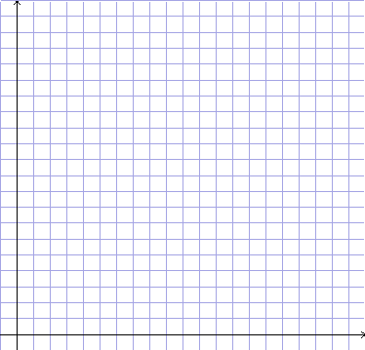

- Find the mean, median, and mode for the number of years of firefighting experience.

- Find the mean, median, and mode for the age in years.

- Find the mean, median, and mode for the score on safety test. Note: Use 1, 2, and 3 to calculate for minimum, above minimum, and maximum.

- Find the mean, median, and mode for the 3-mile 45-pound pack test.

- Designate the mean of each category on the correct category’s grid by marking the mean with an X and then drawing a horizontal line parallel to the horizontal axis through the X across the entire graph. Include this symbol X in the legend of your graph. An example is X = arithmetic mean.

- Designate the median of each category on the category’s grid by marking the median with an O and then drawing a horizontal line parallel to the horizontal axis through the O across the entire graph. Include this symbol O in the legend of your graph. An example is O = median.

- Designate the mode of each category on the category’s grid by marking the mode with a □ and then drawing a horizontal line parallel to the horizontal axis through the □ across the entire graph. Include this symbol □ in the legend of your graph. An example is □ = mode.

- Using the graphs and the measures of central tendency (mean, median, and mode), pick 5 of the best firefighters to form a crew.

- Explain why you picked those 5 firefighters as the best using the graphs and measures of central tendency to defend your choices.

