Alaska Rural Systemic Initiative
High School Mathematics Problems from Alaska

Jesse Thomas Moose Hide Problem

Brenda Jones
bjones@ftyukon.yfsd.schoolzone.net

Standards: Functions and Relationships.

Performance Standards: A4.3.2, A4.3.4, A4.3.5, A4.4.2.

Concepts: Graphing data from a table to a coordinate grid using variables to write algebraic equations, determining slope and y-intercept.

Carnegie Chapter: Formulas, Tables of Values and Graphs, Linear equations: Solving, Graphing, Intercepts, and Slope.

Overview: Jesse Thomas earns money for college by tanning moose hides.
Jesse Thomas Moose Hide Problem

Jesse Thomas shot three moose for meat and wants to save the skins to tan and sell in Fairbanks. A high quality skin can sell for $1,000. He feels he can produce 3 hides a season working alone, 6 hides a season with 2 people tanning, and 9 hides a season with 3 people tanning.

- How many hides can he produce with

  - 2 helpers?

  - 4 helpers?

  - 5 helpers?

Write a complete sentence describing how you found your answers. Write an algebraic equation for this situation. Define any variables.

- Jesse wants to attend UAF in two years and projects he will need $10,000 for his first year. He pays a helper $400 per hide for his tanning work. How much will he net for

  - 3 hides?

  - 10 hides?

  - 15 hides?

  - 20 hides?

Write a complete sentence explaining how you found your answers.

- Write an expression for this situation. Define any variables.

- How many hides will he need to earn

  - $1,200?

  - $1,800?

  - $2,000?

  - for the full $10,000?

Write a complete sentence explaining how you found your answers.

- Jesse saved $1,200 from his PFD this year to apply toward his school expenses. How many hides must he sell to have a total of

  - $1,800?

  - $4,200?

  - $7,200?

  - the full $10,000?

Write a complete sentence to explain how you found your answers.

- Use the information from question 5 to complete the chart below

Labels
Units |  | Dollars
Expressions
 | 1
 | 2
 | 3
 | 4
 |  | 4200
 |  | 7200

- Use the information from the chart to draw a graph. Label axes, indicate intervals, and create a title for the graph.

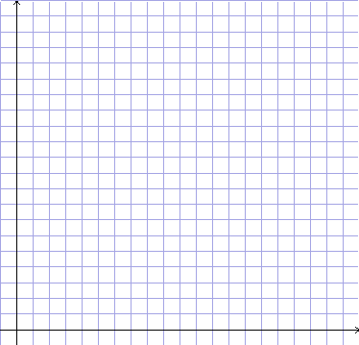
- Should the dots on the graph be connected? Why or why not?

- a) If the dots were connected, what would be the slope of the line?

b) Explain the meaning of slope.

- a) What would be the y-intercept of the line?

b) Explain the meaning of the y-intercept.

