Alaska Rural Systemic Initiative
High School Mathematics Problems from Alaska

Stanley Jonas Travel Problem

Brenda Jones
bjones@ftyukon.yfsd.schoolzone.net

Standards: Measurement, Functions and Relationships.

Performance Standards: A2.4.2, A4.3.2, A4.3.4, A4.3.5, A4.4.2.

Concepts: Converting from one system of linear measure to another, graphing data from a table to a coordinate graph, using a graph to make predictions.

Carnegie Chapter: Analyzing Data and Making Predictions.

Overview: Stanley Jones is traveling from Fort Yukon to Old Crow, Canada. Students calculate miles per gallon and convert from English to metric measurements.
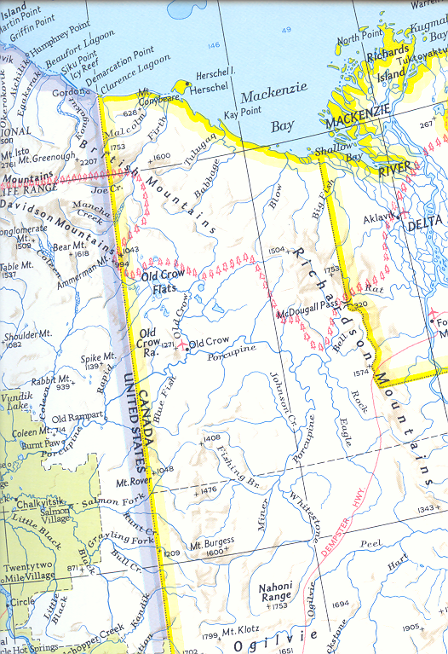
Stanley Jones Travel Problem

Part 1

Stanley Jones is driving his snow machine from Fort Yukon to Old Crow, Canada for Spring Carnival. The gas tank on his snow machine holds ten gallons. He finds that he can get, on average, 28 miles per gallon of gas.

- How many miles can he drive with

  - 5 gallons?

  - 7 gallons?

  - 20 gallons?

- Find an algebraic expression for this situation. Explain your reasoning in complete sentences.

- How many gallons of gas will he need to drive

  - 280 miles?

  - 350 miles?

  - 56 miles?

- Use this information to complete the table.

Labels
Units
Expressions
5
7
20
280
350
56

- Use the information from the chart to draw a graph. Label axes, indicate intervals, and create a title for the graph.

- If it is 150 miles from Fort Yukon to Old Crow how many gallons of gas does Stanley need?

- The first opportunity that Stanley will have to gas up is in Chalkyitsik, which is 70 miles away. If he began the trip with a full tank of gas,

  - How many gallons will he use from Fort Yukon to Chalkyitsik?

  - How far beyond Chalkyitsik, can he drive if he does not fill up there?

- Explain how to use the graph to find how many gallons Stanley would need to go 70 miles to Chalkyitsik.

- How far beyond Chalkyitsik, could Stanley travel if he filled up in Chalkyitsik?

Stanley Jones Travel Problem

Part 2

When Stanley Jones leaves Alaska and enters Canada, he notices that the distances are given in kilometers instead of in miles. He knows that one mile is approximately 1.6 km.

- How many kilometers will Stanley drive if he travels

  - 2 miles?

  - 10 miles?

  - 20 miles?

- Write an algebraic expression for this situation. Define your independent and dependent variables.

- How many miles will he drive if he travels

  - 16 kilometers?

  - 32 kilometers?

  - 100 kilometers?

- Use the information to complete the following table.

Labels
Units
Expressions
2
10
20
100
64
120

- Use the information in the chart to draw a graph. Label axes, indicate intervals, and create a title for the graph.

- a) Use the graph to check how many kilometers Stanley would travel if he went 50 miles.

b) Use the graph to check how many miles Stanley traveled if he went 110 kilometers.
Extension Questions

- If Stanley pays $2.50 per gallon of gasoline and his 4 wheeler get 30 miles per gallon, how much will it cost to drive 48 kilometers?

- Explain in a complete sentence how you got your answer.

- Write a mathematical procedure for finding the cost given a certain number of kilometers.

- Use this procedure for finding the cost of driving (round to the nearest cent)

  - 80 kilometers?

  - 240 kilometers?

  - 160 kilometers?
- In order to find the number of kilometers Stanley can drive after spending $10 on gas, you need to “undo” the procedure from the previous problem. Work backwards, show your work and find the number of kilometers Stanley can drive.

- Use the same procedure to find the number of kilometers Stanley can drive after spending

  - $35 on gas?

  - $15 on gas?

- Complete the following chart comparing kilometers to cost of gas

Labels
Units
Expressions
80
240
$35.00
$15.00
$25.00

- Use the information in the chart to create a graph. Label axes, indicate intervals and give a title to the graph.

- Use the graph to estimate how much Stanley will need to spend on gas to travel 560 kilometers.

- Use the graph to estimate how far Stanley can drive if he spends $8 on gas.

